WORKING WITH THE FILE SYSTEM LAB

**Accessing the AWS Management Console**

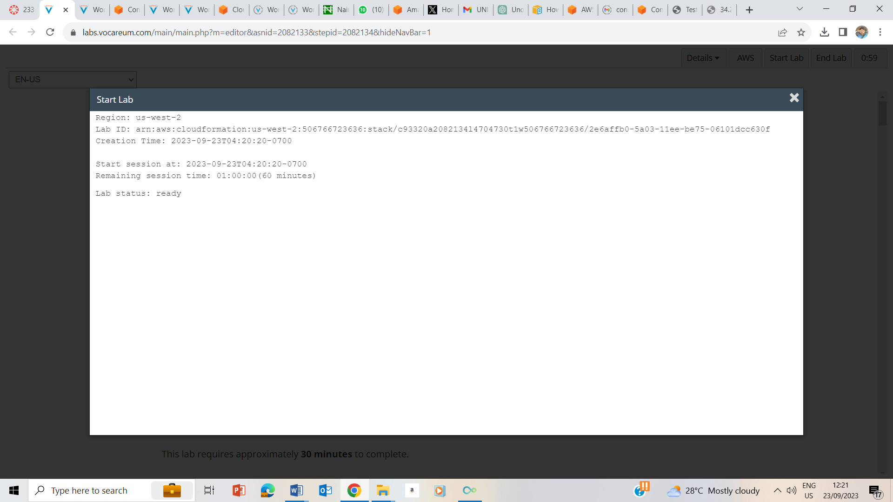

Lab status is ready

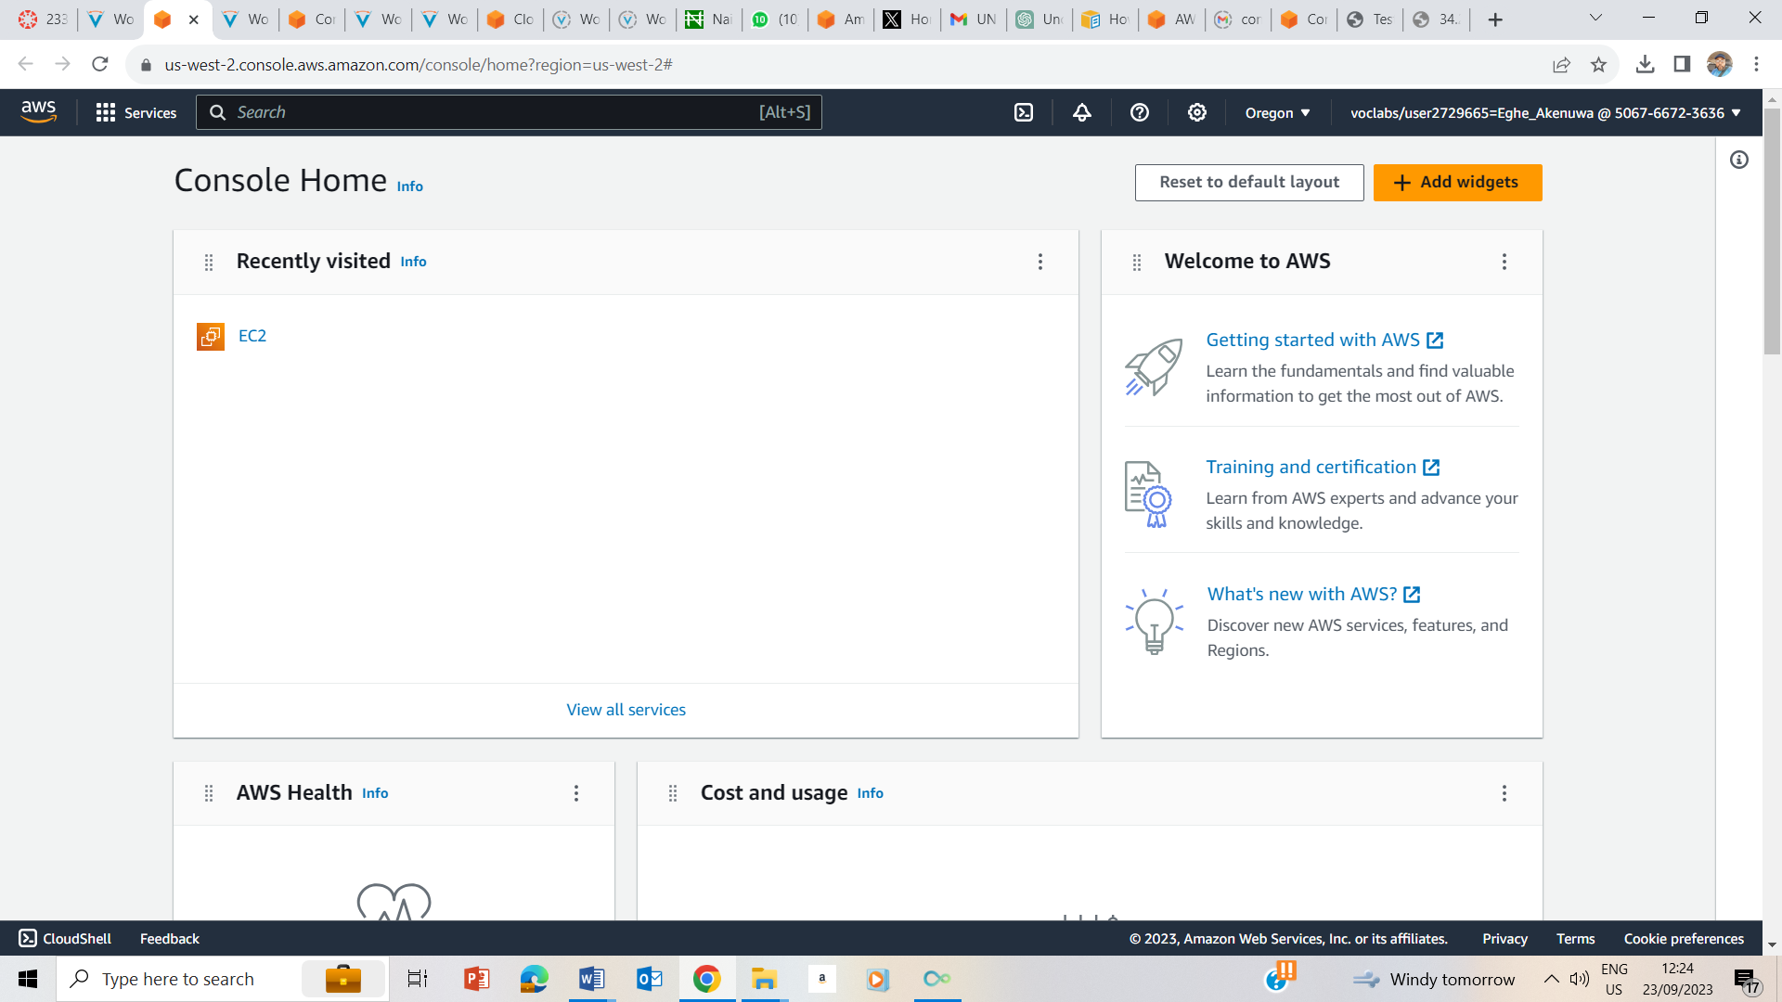

Clicked AWS to take me to the AWS Management console

## Task 1: Use SSH to connect to an Amazon Linux EC2 instance

### Windows Users: Using SSH to Connect

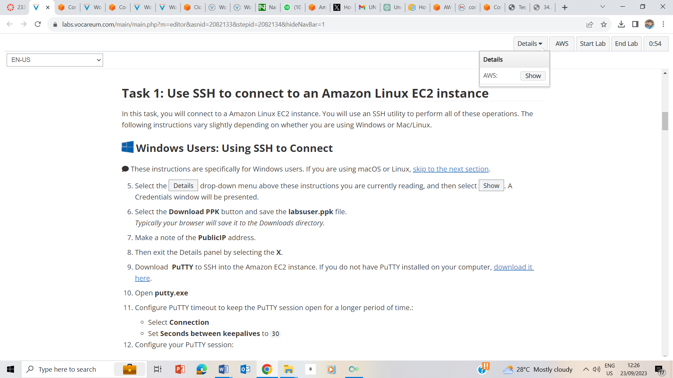

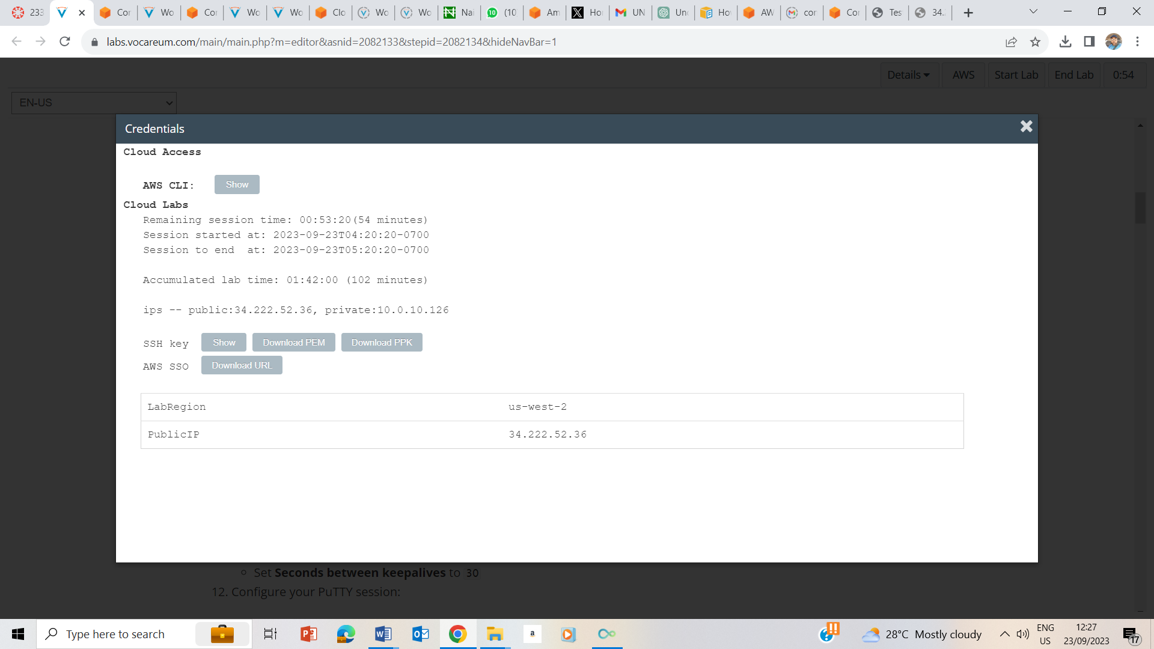

Clicked on AWS dropdown box and clicked on show to reveal the credentials page, downloaded PPK and also noted the public ip address .

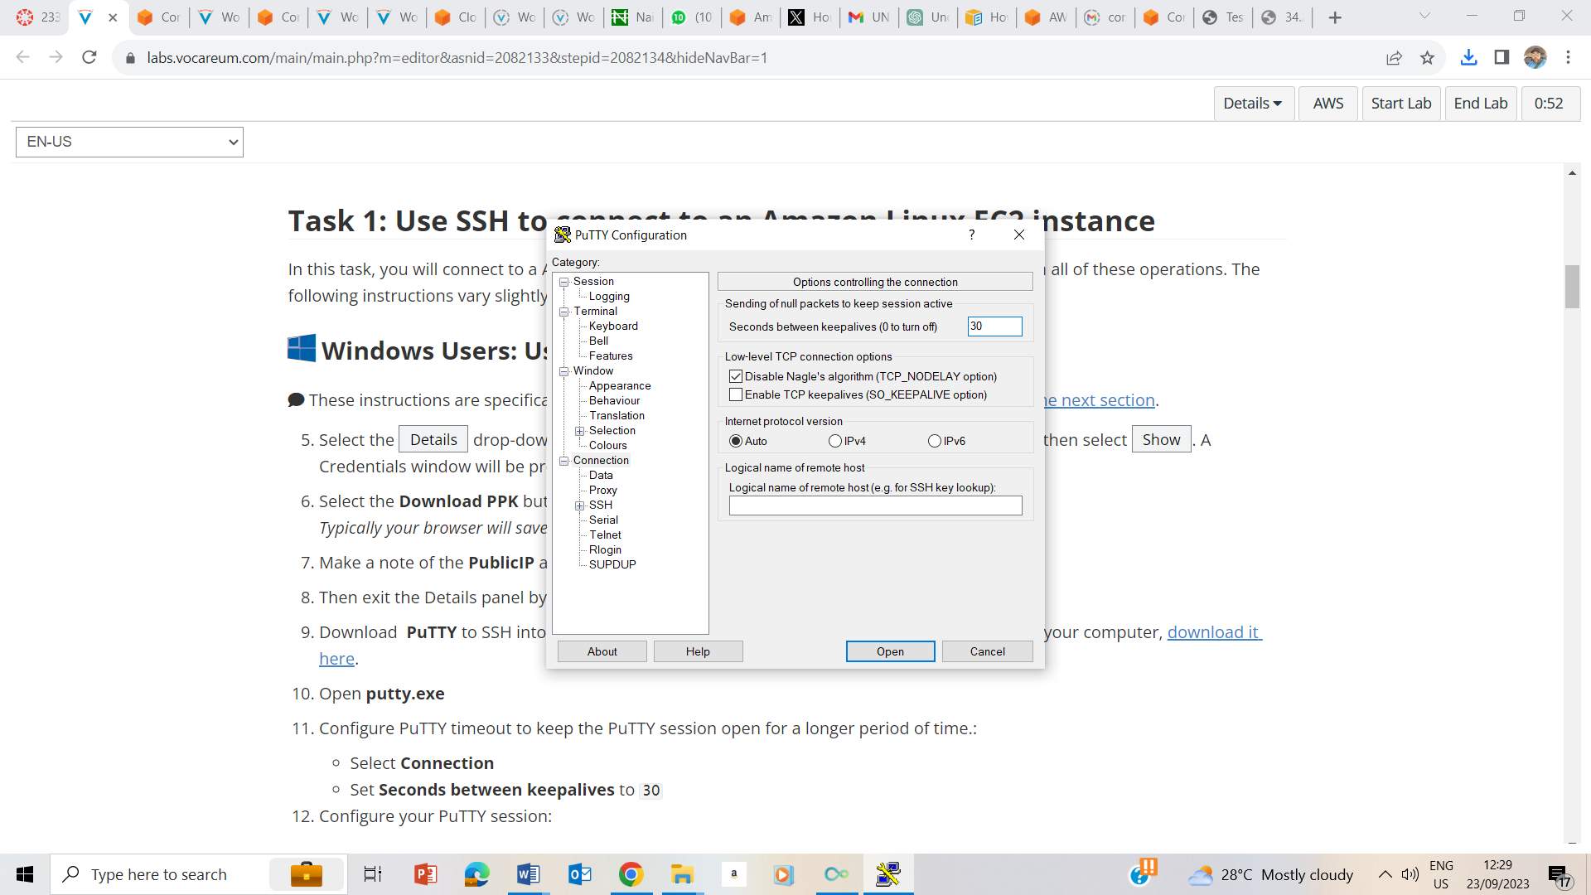

Downloaded putty, ran putty.exe , selected connecton and set seconds to staylives 30.

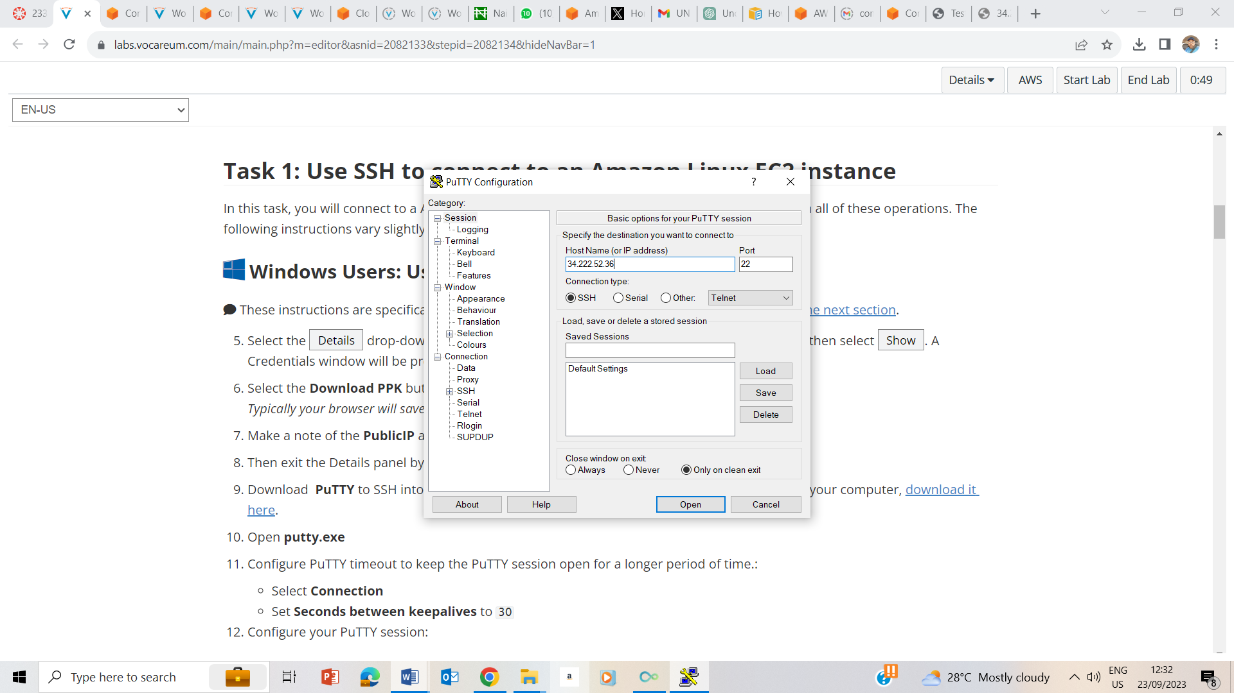

On the session, I input the public ip address that I had previously noted, clicked on open and open again.

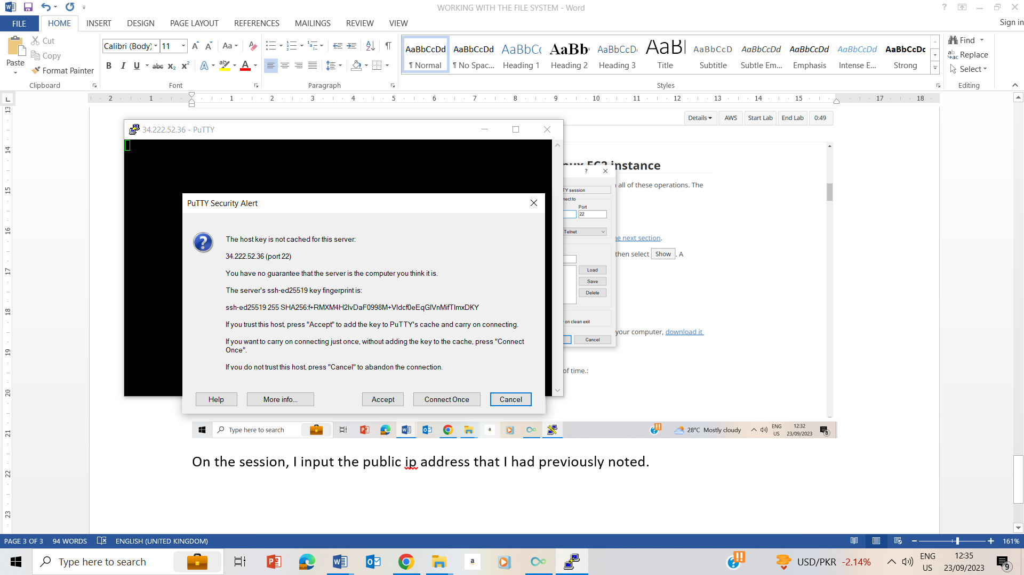

I clicked on accept to trust and connect to the host.

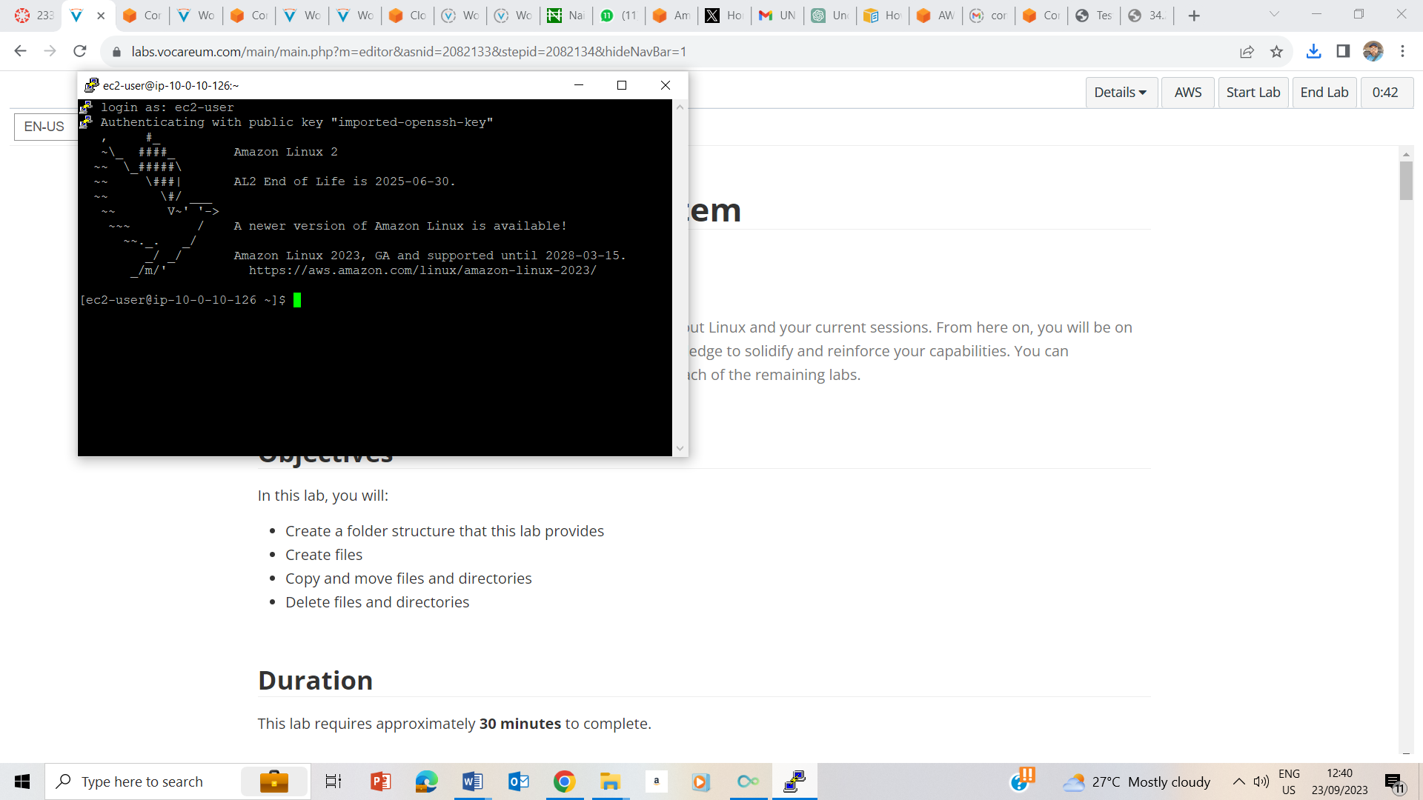

connected

## Task 2: Create a Folder Structure

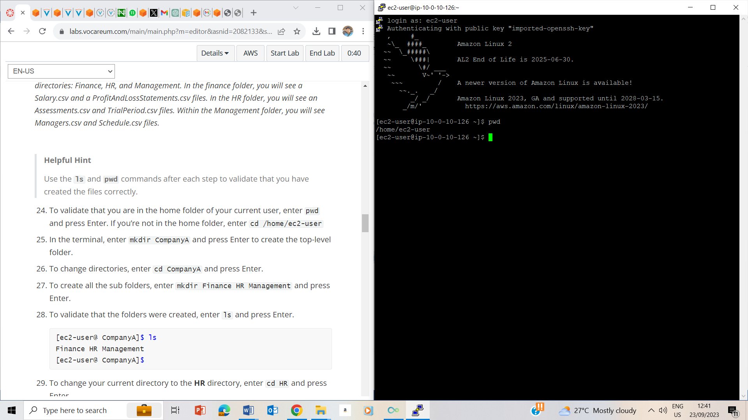

Pwd to confirm if I am on the home directory, which I am.

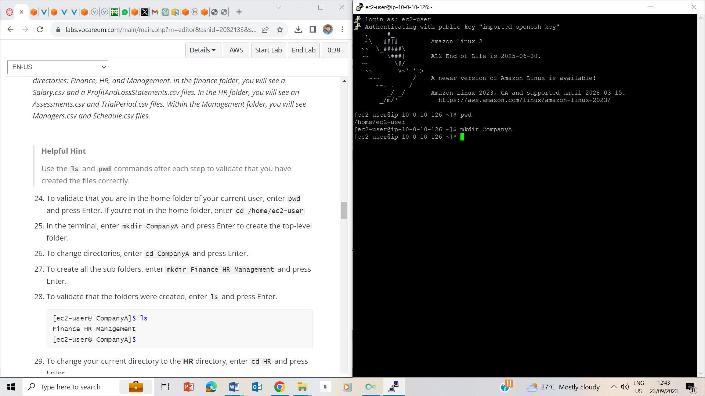

Mkdir CompanyA is to create a top level folder CompanyA

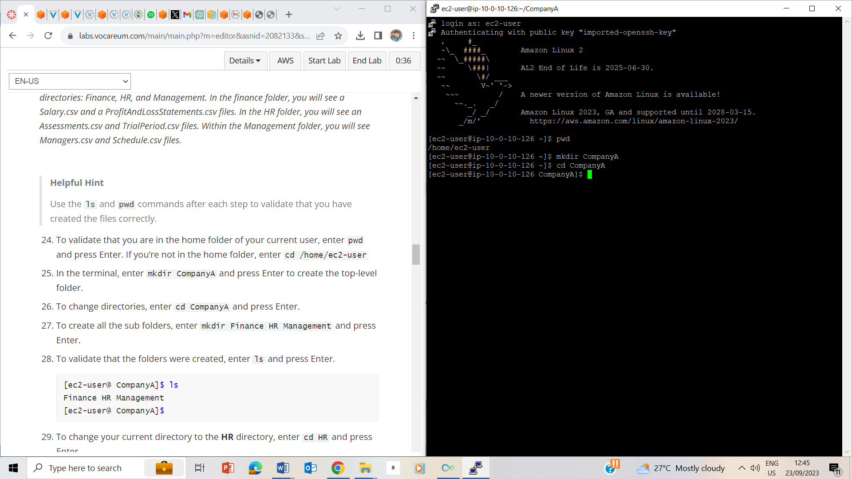

Changed directory to CompanyA

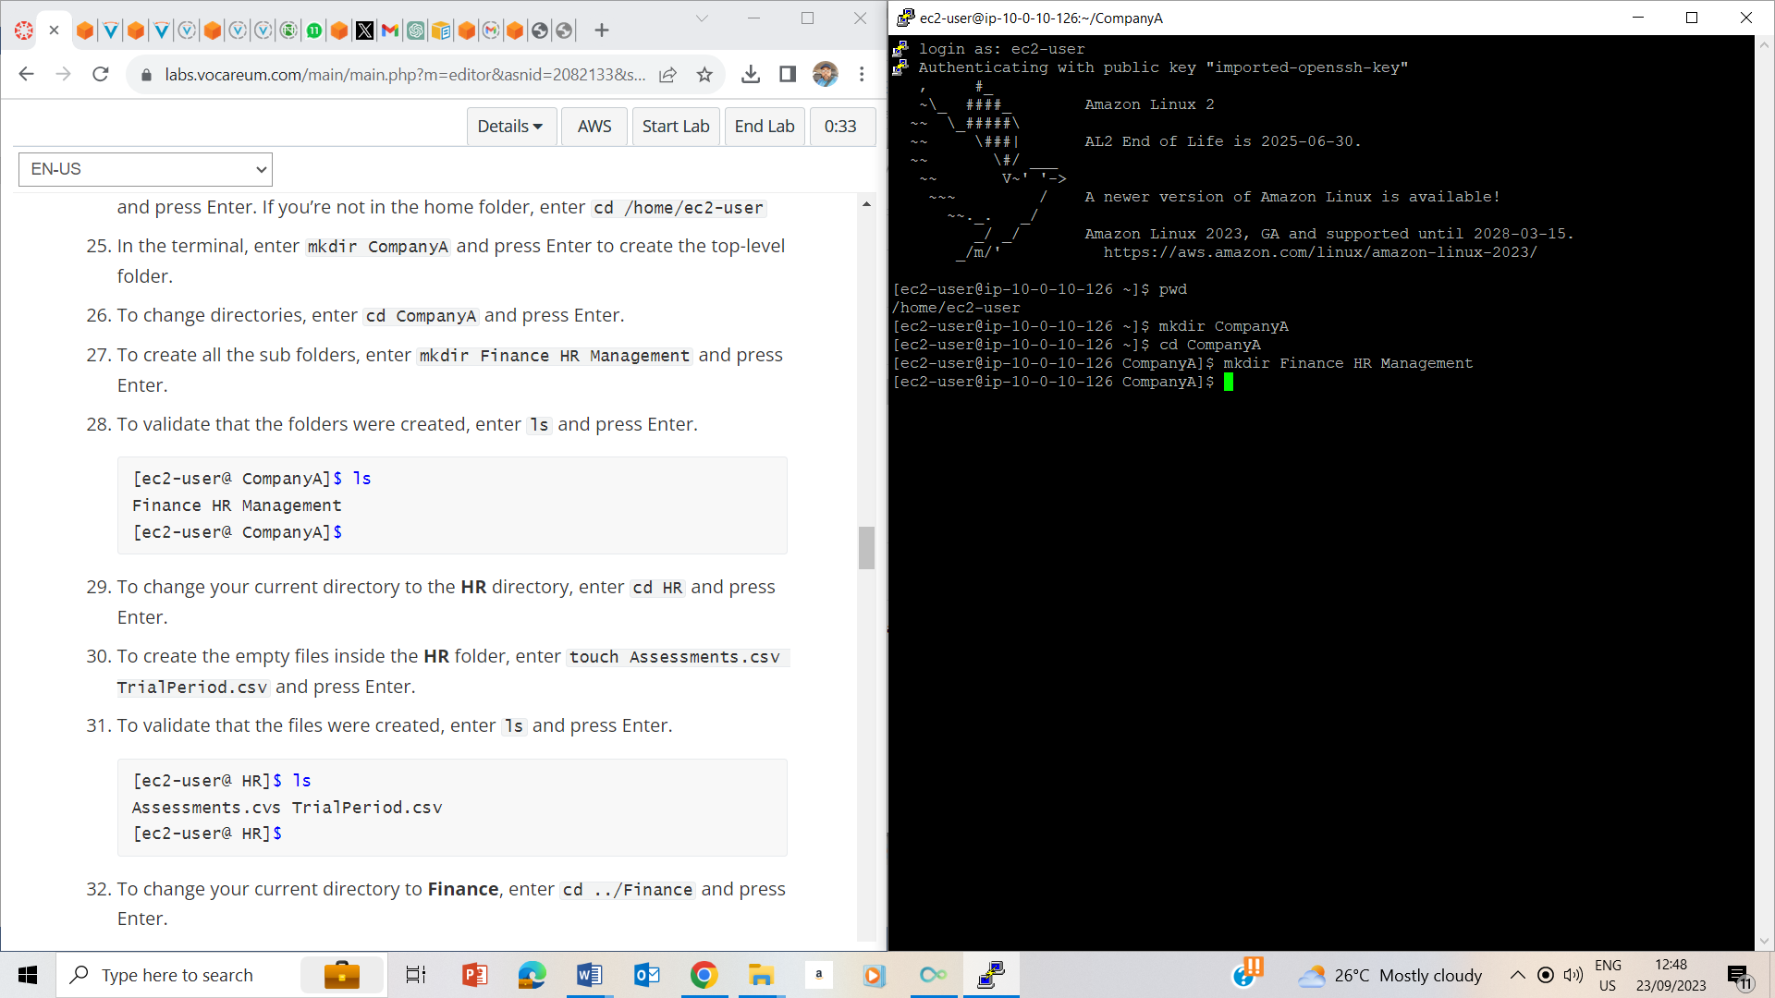

Creating Finance, HR and Management Folders

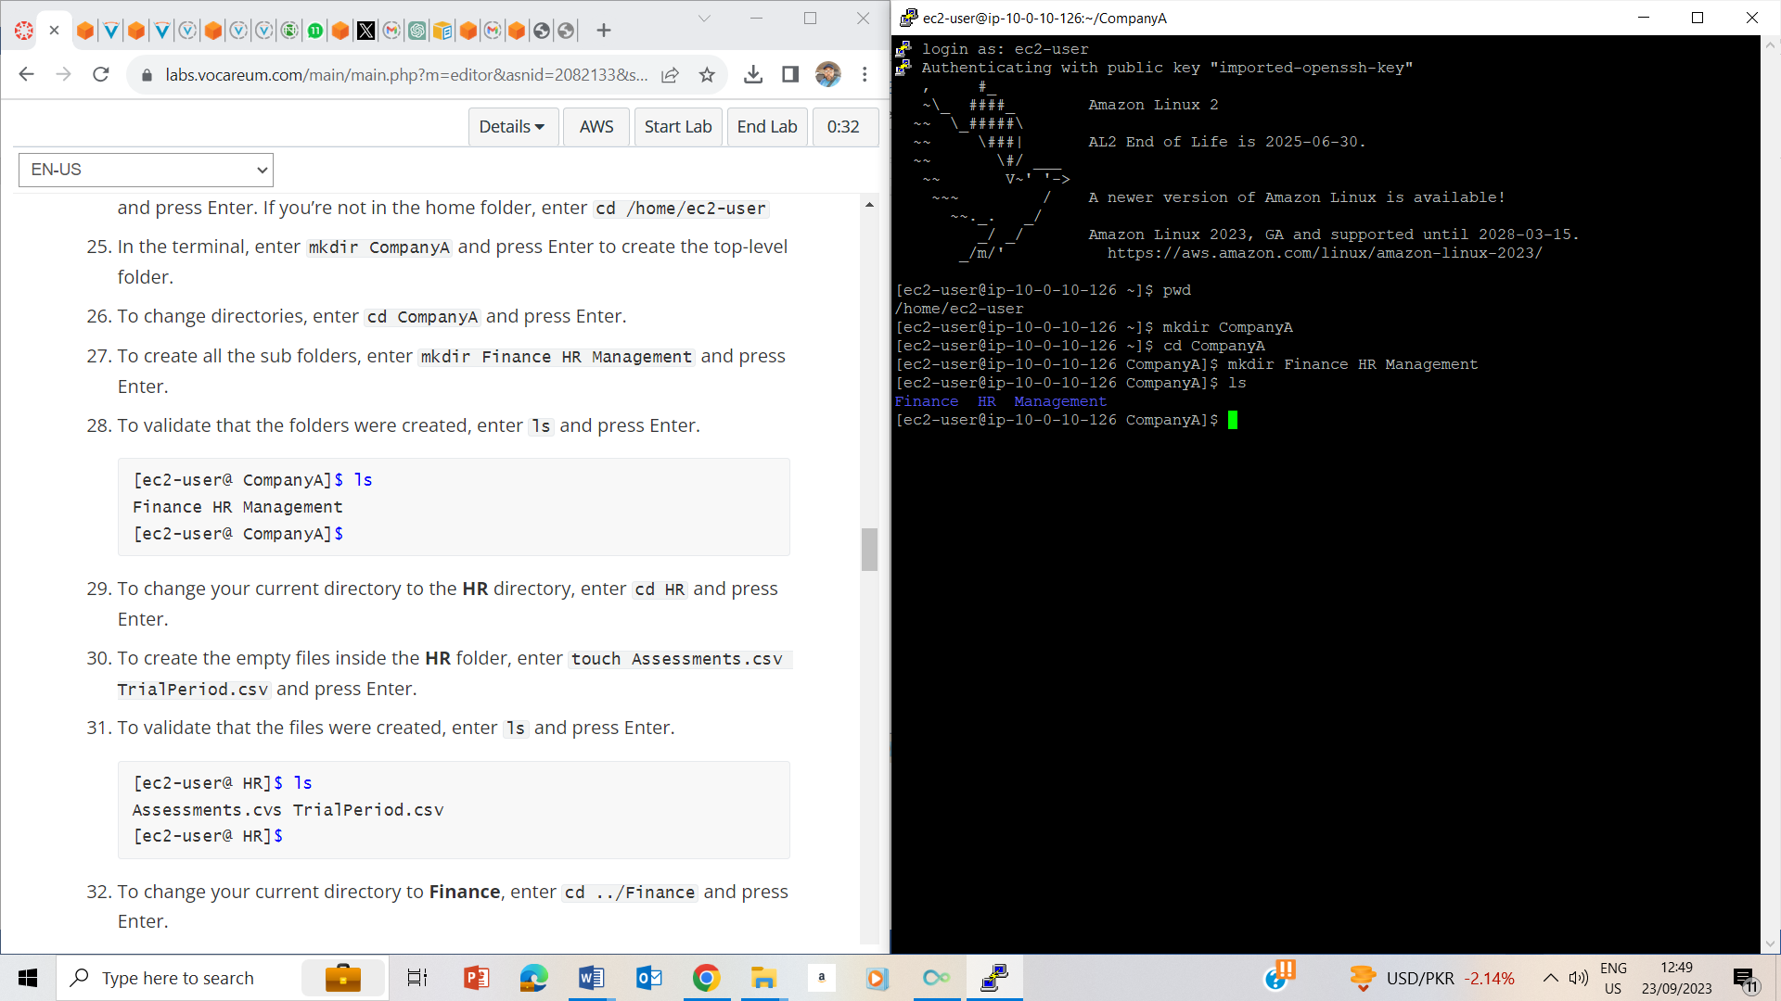

Validating the created folders

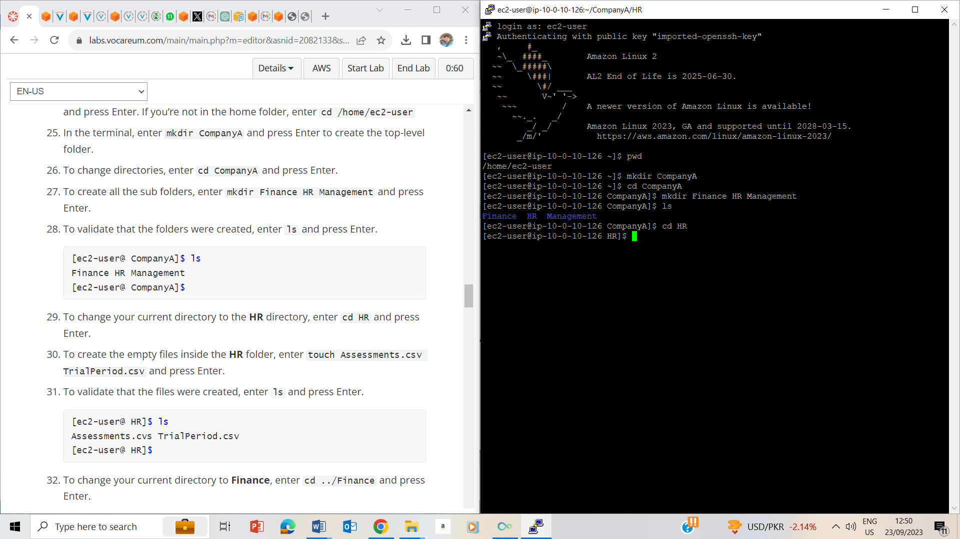

Changed directory to HR

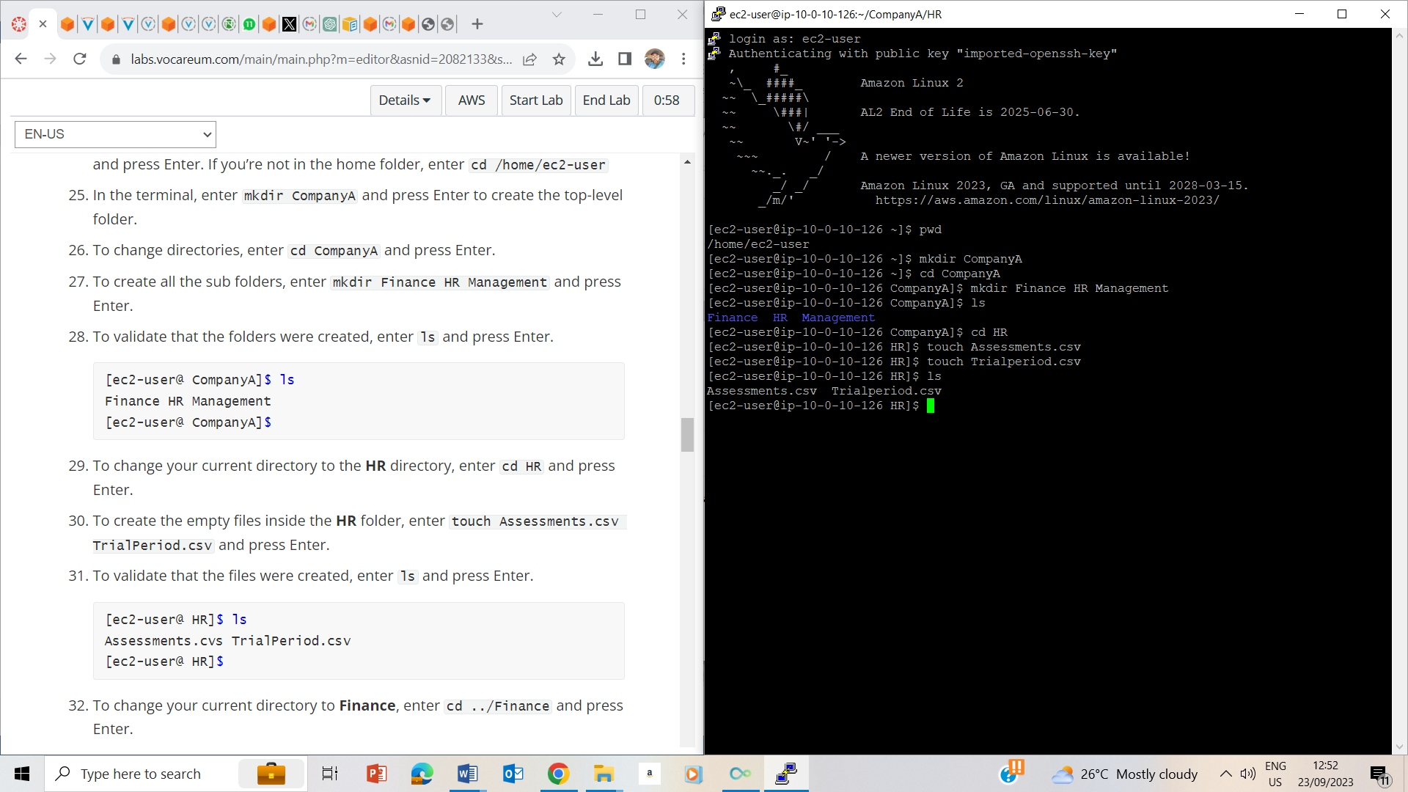

Touched Assessment.csv and TrialPeriod.csv to create Assessment and Trial period files in HR folder.

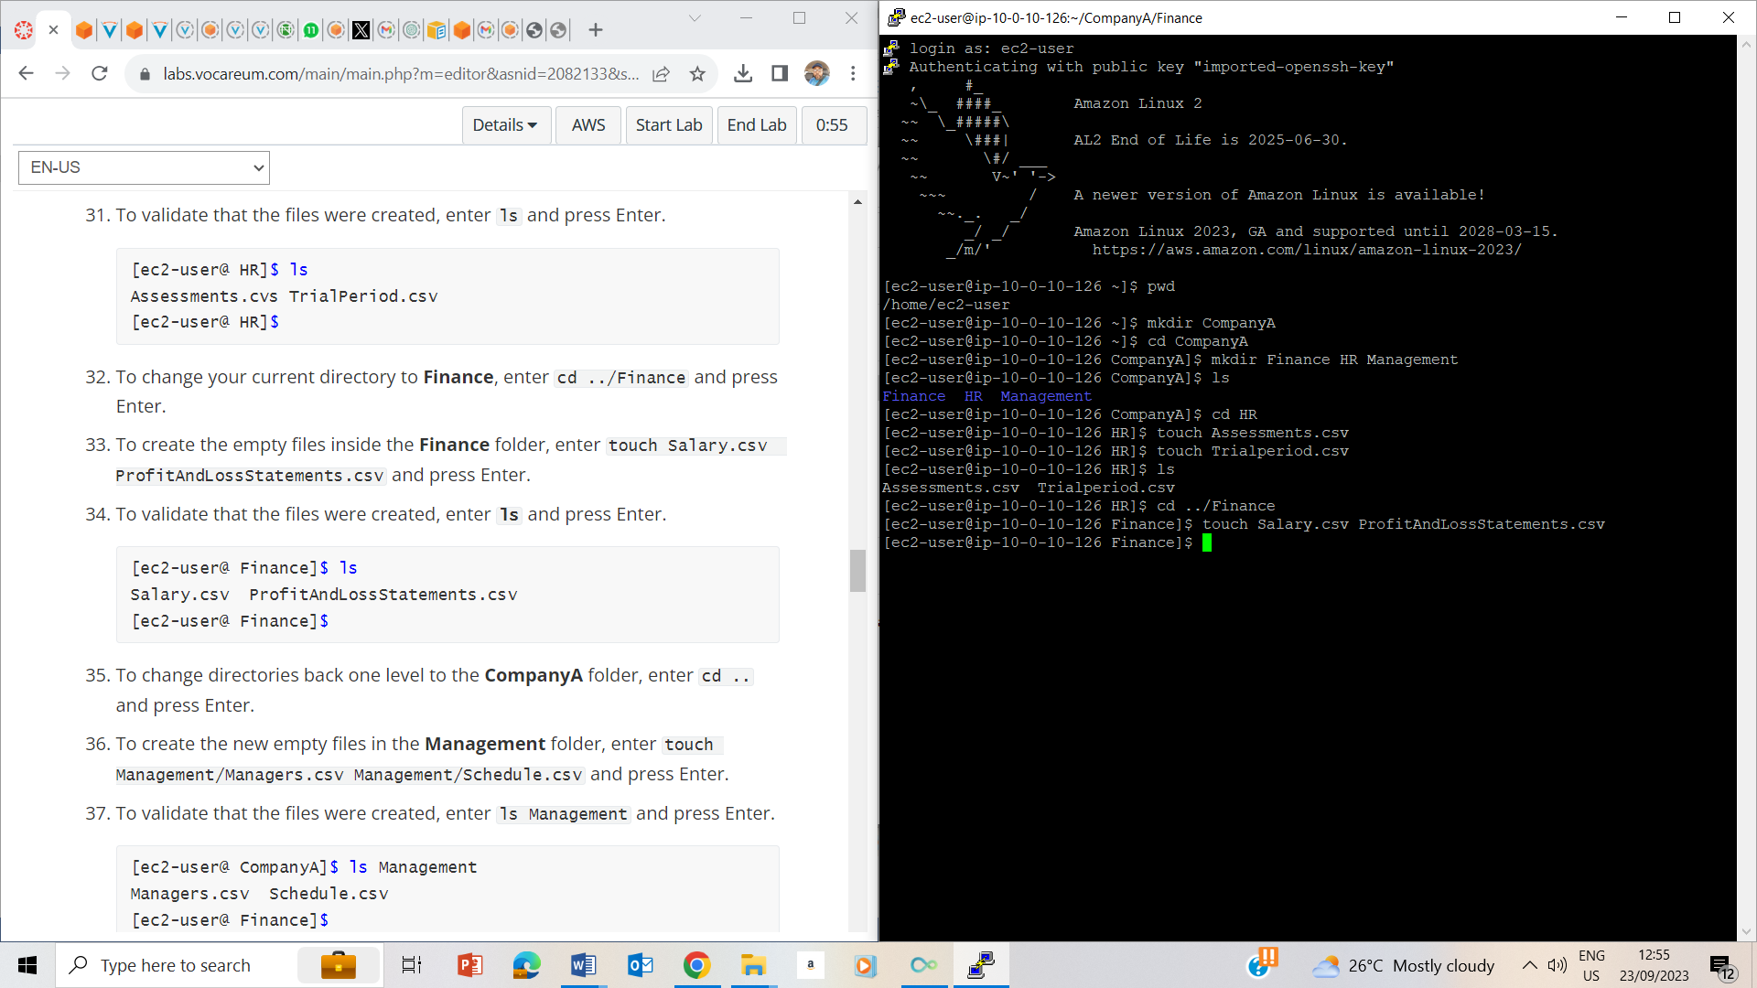

Touched salary.csv and ProfitandlossStatements.csv to create Salary and Profit and loss statement files under Finance folder

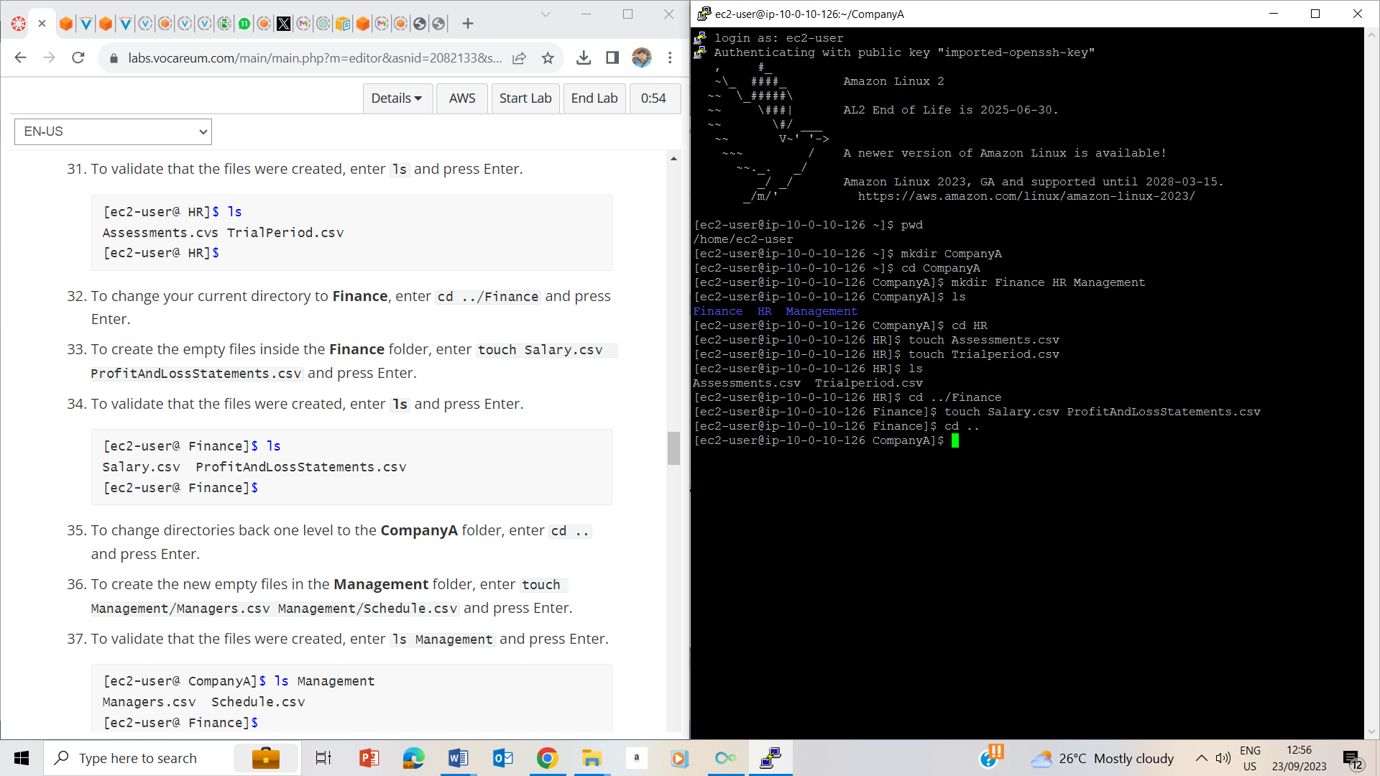

Used cd.. to return to Company folder

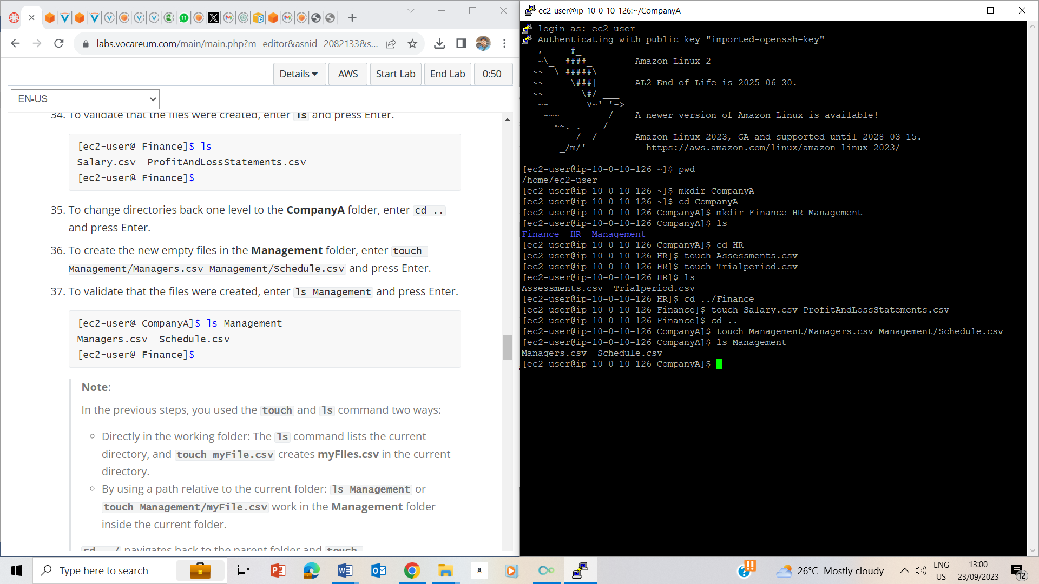

Created managers.csv and Schedule.csv files and confirmed their creation using ls Management command

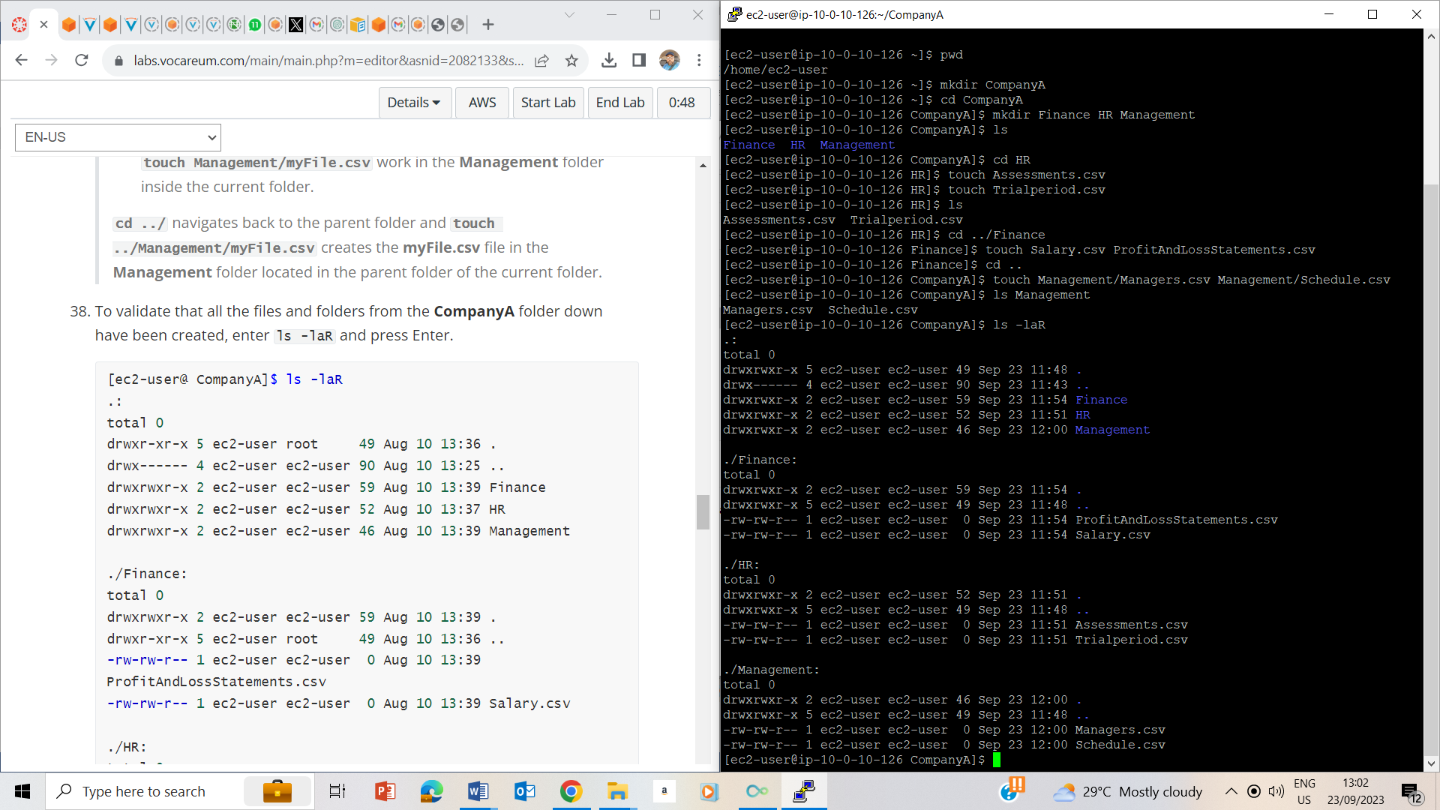

Used ls –laR to validate all the files and folders in CompanyA

## Task 3: Delete and reorganize folders

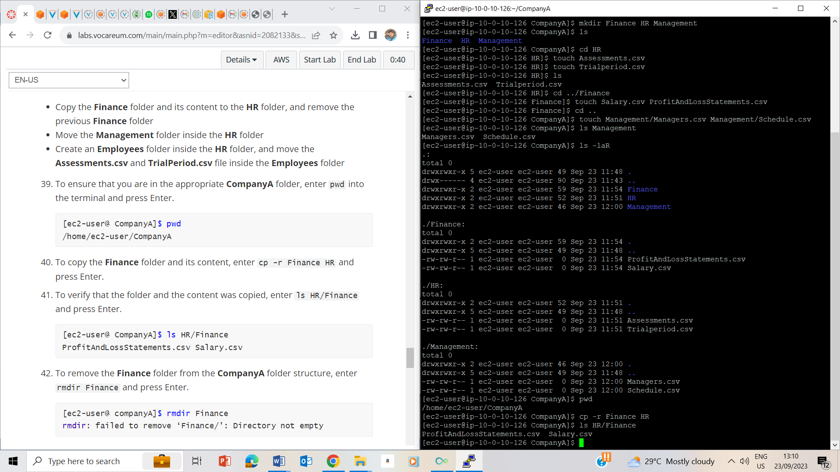

Cp –r Finance HR, copies Finance to HR and ls HR/Finance lists the items in the folder.

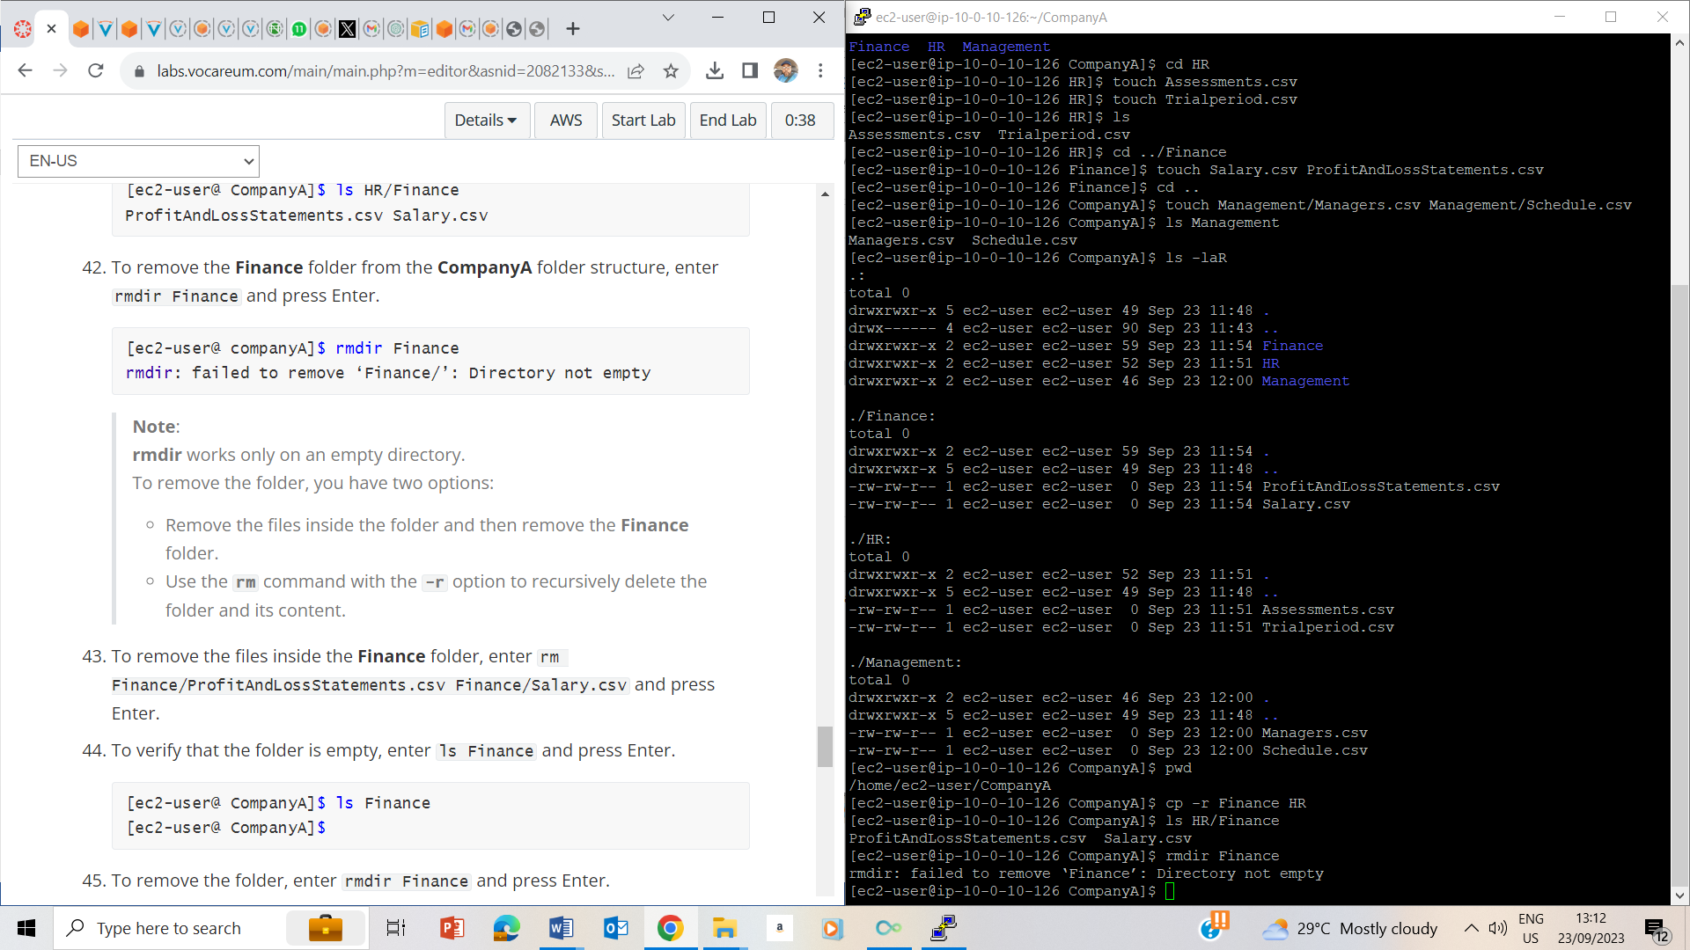

Rmdir Finance couldn’t delete the folder as it has contents.

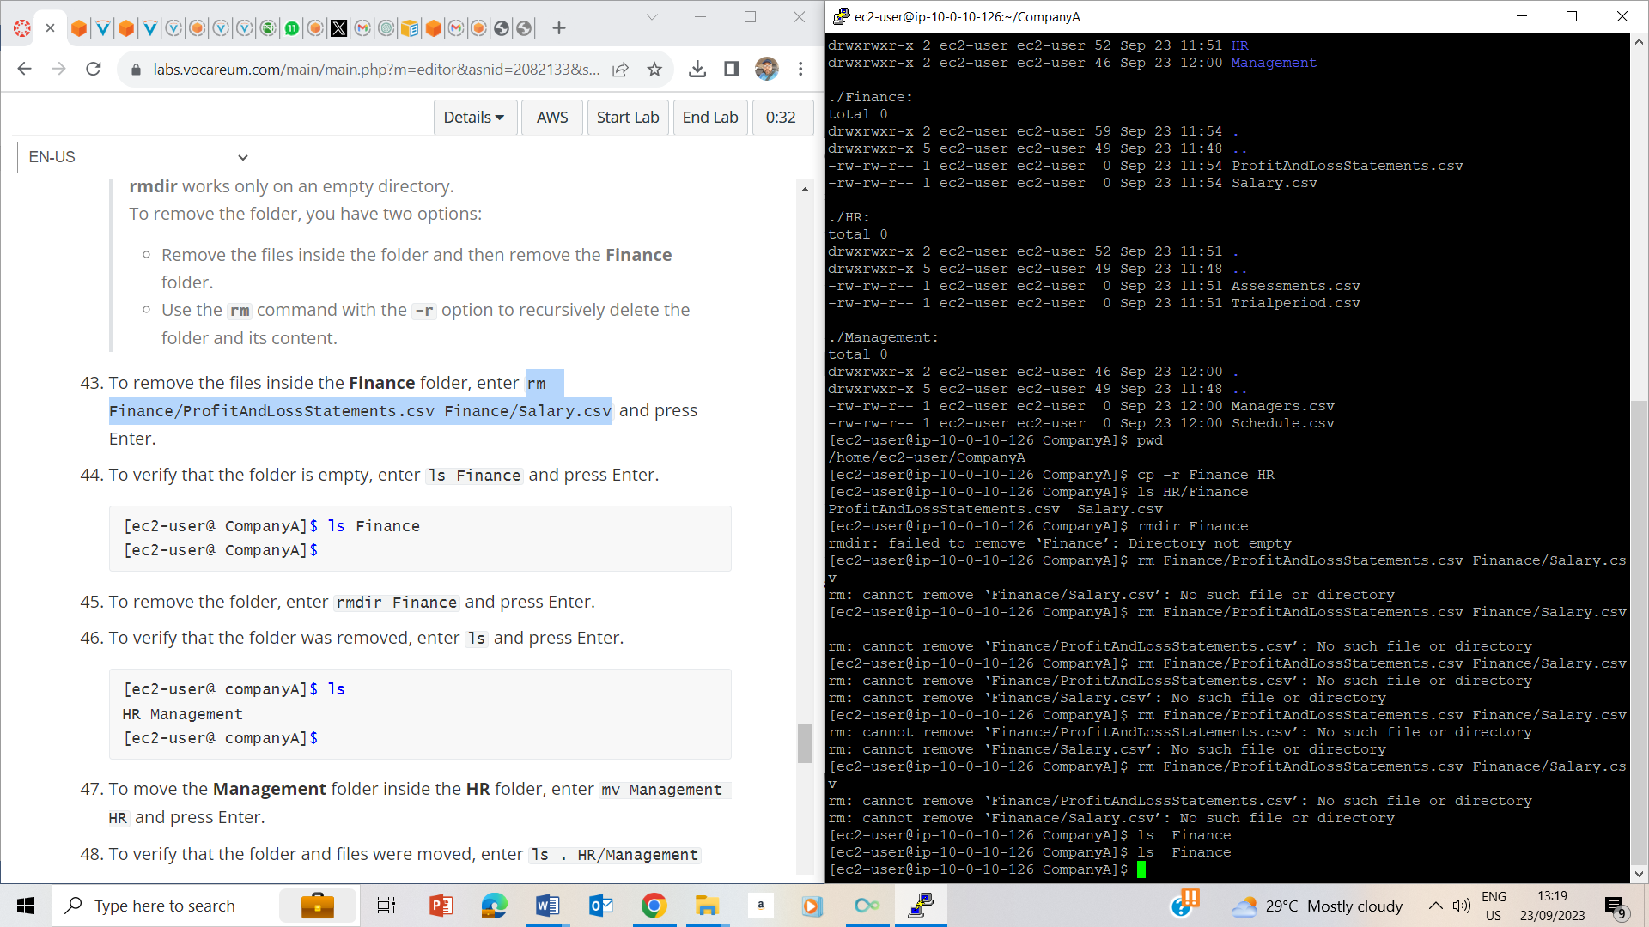

rm Finance/ProfitAndLossStatements.csv Finance/Salary.csv removes the files in the finance folder.

Ls finance shows that there is nothing in the folder.

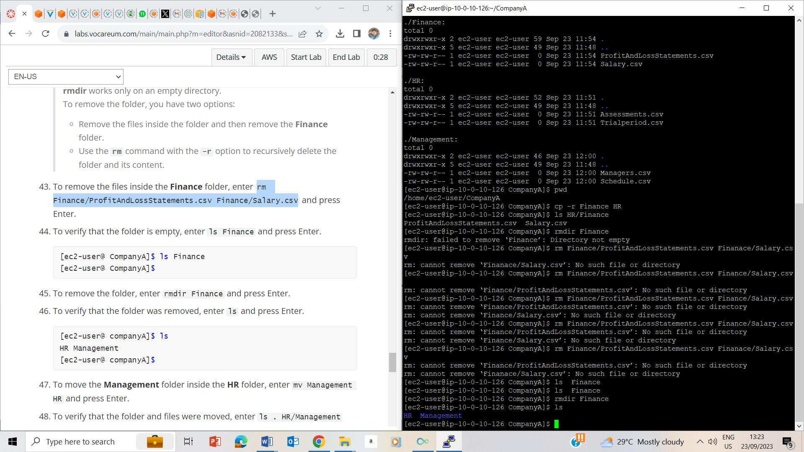

Redir Finance deleted the Finance folder and ls shows theres only HR and Management folder remaining.

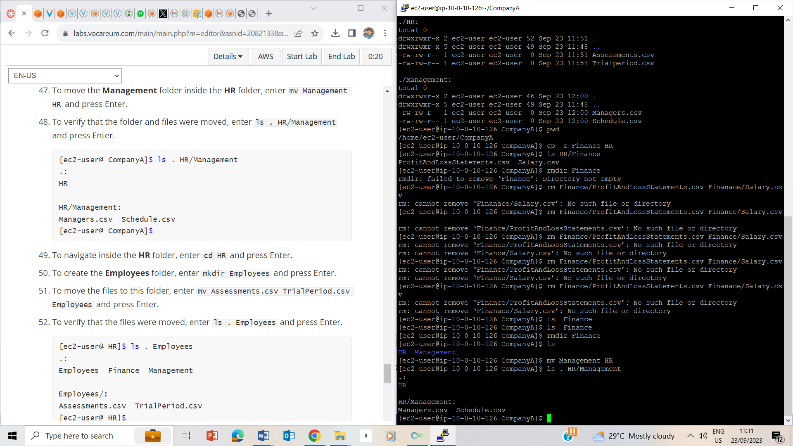

Moved Management file to HR and also confirmed using the ls command.

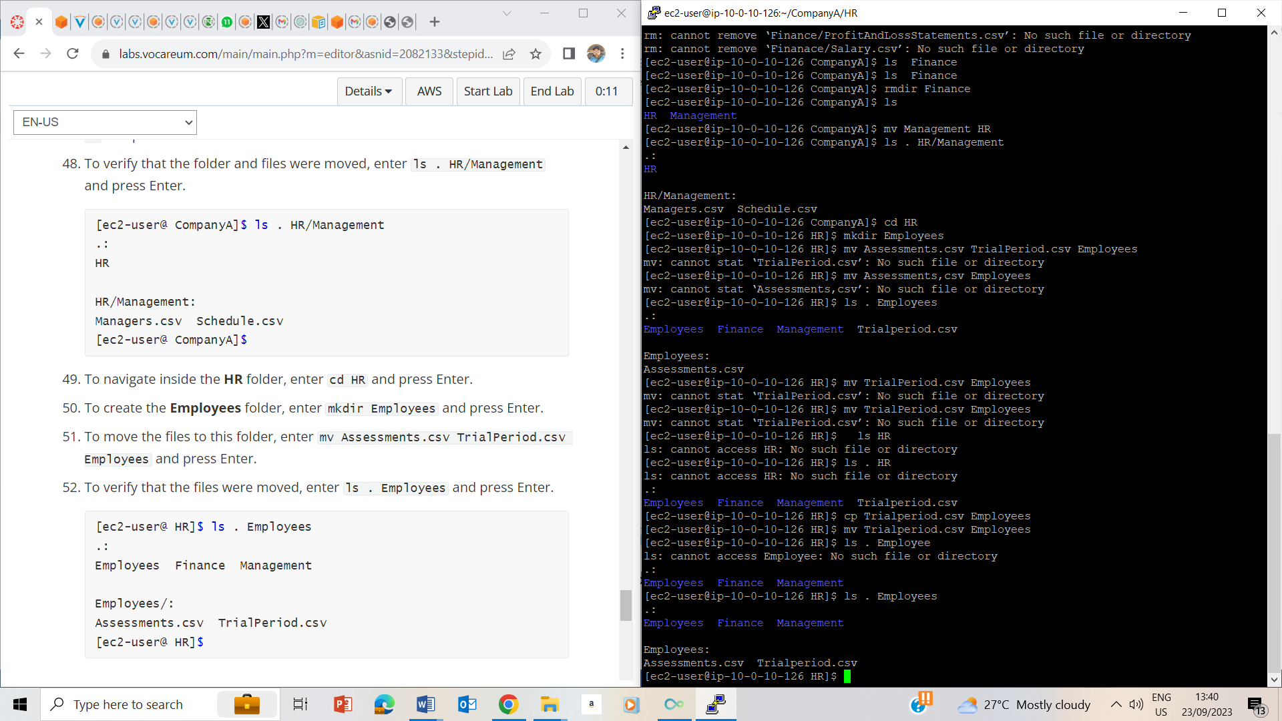

Created a folder called Employee, then moved Trialperiod.csv and Assessment.csv to the Employees folder and confirmed the movement using ls command.

## Lab Complete

